Project Initialization and Planning Phase

Date | 30 January 2026
Team ID | LTVIP2026TMIDS24926
Project Name | Visualization Tool for Electric Vehicle Charge and Range Analysis
Maximum Marks | 3 Marks
Define Problem Statements (Customer Problem Statement Template):
Create a problem statement to understand your customer's point of view. The Customer Problem Statement template helps you focus on what matters to create experiences people will love. A well-articulated customer problem statement allows you and your team to find the ideal solution for your customers' challenges.
Throughout the process, you’ll also be able to empathize with your customers, which helps you better understand how they perceive your product or service.
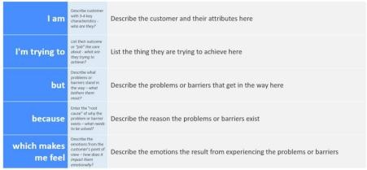
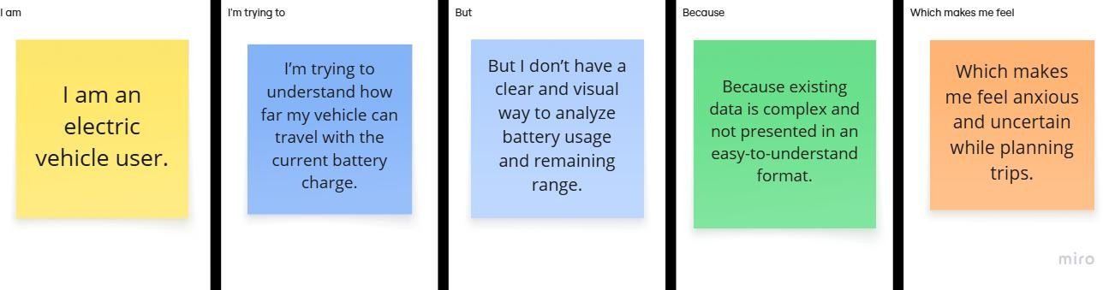

Problem Statemen t (PS) | I am (Customer) | I’m trying to | But | Because | Which makes me feel

PS-1 | I am an electric vehicle user. | I’m trying to understand how far my vehicle can travel with the current battery charge. | But I don’t have a clear and visual way to analyze battery usage and remaining range. | Because existing data is complex and not presented in an easy-to- understand format. | Which makes me feel anxious and uncertain while planning trips.
PS-2 | I am a fleet manager / EV analyst. | I’m trying to monitor charging patterns and range efficiency of electric vehicles. | But I lack an interactive visualization tool to compare charge levels, distance covered, and efficiency. | Because raw datasets and tables do not provide meaningful insights quickly. | Which makes me feel frustrated and inefficient in decision- making.

